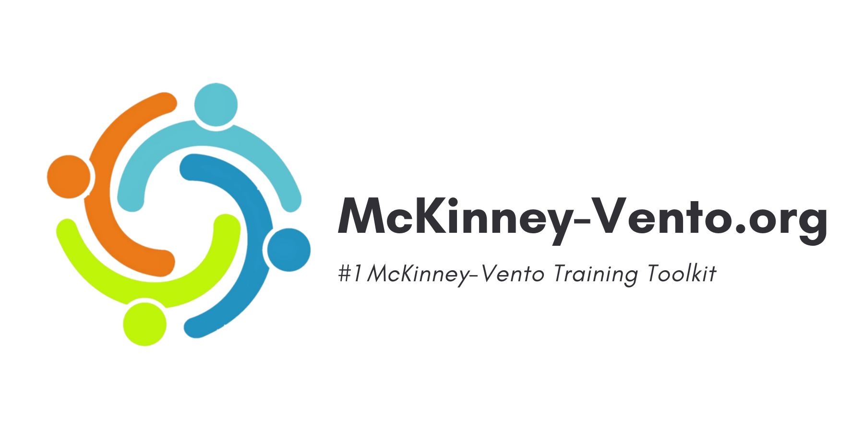
COMMUNITY PARTNERS WELCOME LETTER

Hello everyone,

My name is ______ and I work at ____________ I am the designated Homeless Liaison for our school/district. This is a federally mandated position, with specific requirements that are aimed to ensure that we identify and support our students who are experiencing homelessness.

One of my many federally mandated requirements is to deliver training to all staff within our school district on the laws related to homelessness and ways to properly identify these students. We aim to increase the identification of homeless students in our district, impacting Local Educational Agency (LEA) funding for students experiencing homelessness and for Homeless Education Programs.

Given our limited resources and time to deliver this training in person, we have teamed up with Mckinney-Vento.org to provide an online alternative that is faster, easier, and more cost-effective. It should take you LESS THAN 15 minutes to complete.

This course is completely optional for you and your staff, but it would be extremely helpful for them to be able to identify our students in the community who may be experiencing homelessness, and what you can do to help.

Please review your login or registration instructions on the next page.

If you encounter any technical issues or need assistance, please submit a ticket to the McKinney-Vento support team: Click Here to Submit a Ticket

REGISTRATION INSTRUCTIONS
Please Note: Follow these instructions if you’ve never created an account on McKinney-Vento.org
- To create a new account, Click Here to Register.
- Fill out your name and school email address. (If your email address is not working, Click Here to Submit a Ticket)
- Select “I am NOT a liaison.” (A Liaison is a person designated to train staff members on identifying a child experiencing homelessness. If you do not have the job title of “Liaison” please choose “I am NOT a liaison”)
- Select your State, County, District, School (select “Community Partners” since you’re not at a specific school) and then the same for Role.
- You will receive an email at your provided email address with instructions on creating your account password. Please allow 15 minutes for the email arrival and be sure to check your spam/junk folders for this email if it seems you have not received it.
- Once you have created your password, you will be able to log in and start taking your course. If you don’t see your course, click the Learn tab on the top right of the page.
- Once you complete the course, you can download your certificate and submit to your liaison or supervisor. Click Here to Learn How

NEED HELP?

Here are a few ways for you to get help when you need it:

1. Chat with the MV ChatBot - On every page at McKinney-Vento.org, you'll find our MV Helper in the bottom right corner. Chatting with our bot will pull up one of the over 30 articles to help with your question!

2. Visit our Help Center - If you'd like to get a quick answer to your question, you can visit and search our Help Center here: https://knowledge.mckinney-vento.org/knowledge

3. Submit a Support Ticket - If you are experiencing any technical issue during registration or training that cannot be answered in the Help Center, please submit a Support ticket here: https://link.mckinney-vento.org/CommunityPartnerSupport

